

Winter 2011

***Department of English***

***INKLINGS***



“In 1600 there was no canon, literary history not yet having been invented.”

—Hugh Kenner

**MARCH OMAD PROFILES THREE ENGLISH DEPARTMENT WRITERS AND SCHOLARS**

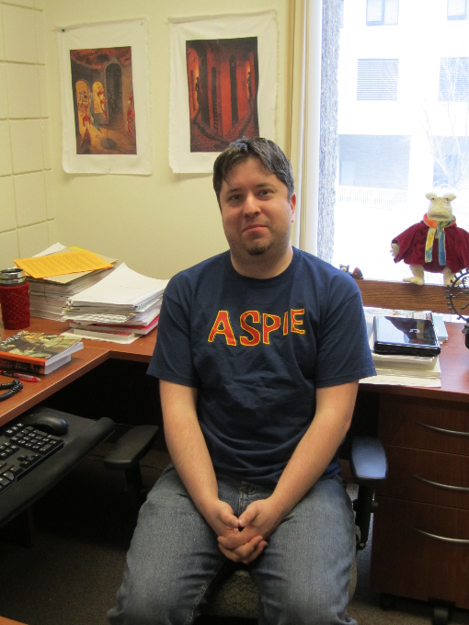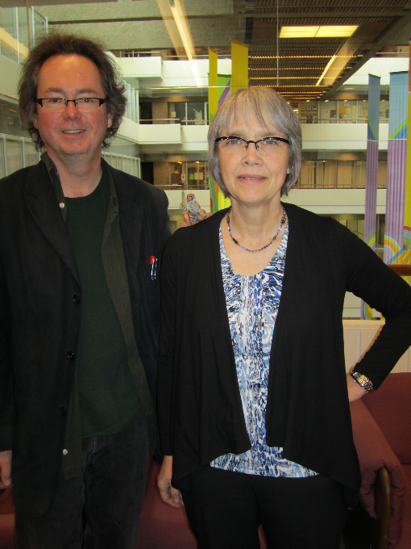

**Michael Trussler & Jeanne Shami Jes Battis**

The March OMAD featured a panel of three professors in the Department of English discussing their varied research experiences and methodologies. Professors Jeanne Shami, Michael Trussler, and Jes Battis each gave an account of recent research experiences, illustrating the range of scholarship being carried out in the English Department.

Jes Battis, who writes fiction and whose teaching interests include creative writing, discussed the role that research plays in his creative writing. He began by discussing his readings on the science of forensics, focusing on how its technologies have shaped his last four novels. From science, Jes moved to Norse mythology, particularly the Poetic Edda as a text that has influenced the young-adult novel he is currently writing. He concluded by speaking about Asperger’s Syndrome and its impact on the young protagonist of his novel in progress.

In a presentation entitled “The Slow Drag of Contingency and Juxtaposition,” Michael Trussler, a poet and fiction writer, also spoke on the relation of research to creative writing. To conduct research for his current project, a poetry MS tentatively titled the *Adorno Elegies*, Mike travelled to New York City and Wash- ington D.C. to visit art galleries and the Holocaust Memorial Museum. This research relies upon contingency, juxtaposition, and the vicissitudes of memory. “One cannot control what paintings a gallery is going to have available for public viewing; furthermore, one can’t predict the personal and historical events that will transpire when one is conducting research,” he remarked. For example, when he planned the trip he didn’t know that the National Gallery would be hosting a Philip Guston exhibit; his work, previously unknown to Mike, has allowed him to write a new kind of poetry. While he was in Washington, the Fort Hood massacre took place, and the Washington Memorial, an obelisk, lowered its flags to half-mast. Because he had spent time looking at the Chirico paintings a week earlier, he is writing a poem that blends de Chirico’s enigmatic piazzas with terrorism, a connection he wouldn’t have made himself. Geographic juxtaposition encourages different associations than those connections he might have made in a monograph or dissertation. Because Vermeer’s painting “A Lady Writing” is near the Holocaust Memorial Museum, Mike has written a poem that ironically blends Vermeer’s portrait with the light present in the sort of boxcar the Nazis used to send Etty Hillesum, another Dutch woman who sat a desk, to her death at Auschwitz. Memory, both contemplative and aleatory, is equally important,” he said, “because one never knows how one will use the material that didn’t make it into one’s notes, but rather flickers at the back of one’s head until it’s eventually recalled.”

Jeanne Shami gave an illuminating account of the always painstaking, sometimes frustrating, but ultimately exhilarating process of writing *The Oxford Handbook of John Donne*, of which she was one of the three editors. Published in February of 2011, the *Handbook* was conceived in the summer and fall of 2005, when Jeanne was approached by the commissioning editor of Oxford University Press to develop a proposal. At that time, Jeanne approached two colleagues, Dennis Flynn and Tom Hester, to co-edit the project with her, and together they formulated a plan that was eventually accepted in November 2011. The editors then developed a detailed table of contents which they sent out to over 100 prospective contributors, inviting them to indicate which of the 54 chapters they would be interested in contributing. The assignments were finalized in the summer of 2006. The project encountered many setbacks, some of them to be expected (the withdrawal of contributors, reassignment of essays, failure to meet deadlines, essays requiring considerable revision), and some of them not (the deaths of three contributors over the course of the project). Permissions for maps and illustrations took over a year. The editors also had to argue over points of principle and detail with copyeditors, proofreaders, and contributors who read the final proofs. When all of the revised essays were completed, two of the editors and Anne James, Jeanne’s research assistant, checked every quotation—both the manuscript and print—in the entire volume. Compiling the bibliography and four indexes was time-consuming and brain-numbing, but vital to the integrity and usefulness of the project. In the very last stages, typesetters for Oxford University Press introduced over a thousand errors, and the editors are still uncovering some of the results of their unasked-for interventions. The editors were assisted immeasurably by the efficient, cheerful, and generous contribution of Anne James, a graduate of our M.A. program. Jeanne says, “We are proud of the volume, and believe it will be useful to scholars and students, but learned a great deal about the level of intellectual effort, commitment, and patience it takes to complete such a project.”

**HEADNOTE**

As you will know, my term as department head ends June 30, 2011. My warm congratulations to Nick Ruddick, who will take on this role in July; Nick’s service to the department and university is already noteworthy—he has been a firm and dedicated citizen and public intellectual, and will be a superb head. I wish him a steady ride. I would also like to take this opportunity to thank you for graciously welcoming me into your “home” over the past three years. It has been sometimes challenging, often-stimulating, always-interesting service—and I am grateful to have had the chance to work with all of you closely. I echo the sentiments of others in saying this is a grand department, with committed and gifted individuals—students, staff, and faculty. Ciao.

**Dorothy Lane**, Department Head

**LUTHER COLLEGE AND SASKATCHEWAN WRITERS GUILD ASK, “WHAT MAKES A SASKATCHEWAN POET?”**

Talking Fresh 9, a co-production of Luther Colelge and the Saskatchewan Writers Guild, happened on March 4-5 at Luther. We invited four writers—Karen Solie, Dan Tysdal, Brenda Schmidt, and our own Michael Trussler—to consider: *What makes you a Saskatchewan poet, if you are one? Does the label “Saskatchewan Poetry” (or “______ Poetry” of any kind) matter? What are the limits to “Saskatchewan Poetry” as a name, a* *concept, a practice, or whatever else it might be?*

Because these questions are so reductive, or so impossible to answer, nobody did, quite. Instead, the writers delivered a provocative set of readings, and papers with titles like these: “Lyric Trap-lines: Thoughts on the Northbound Poem” (Schmidt); “The Cosmopolitan Mountain on the Prairie” (Trussler); and “This Place Will Kill Me One Day: Writing the Southwest” (Solie). Dan Tysdal laid a parody on us: Saskatchewan Poetry as seen from the year 2030 and through the eyes of one Dr. Potemkin of the University of Moose Jaw. It was screamingly funny. Sharp, too.

Things wrapped up with a Happy Hour launch of new books by former Saskatchewan poets Holly Luhning (now a Toronto novelist) and Jennifer Still (now a Winnipeg poet). For more info, see Kathleen Wall’s blog at www.blueduets.blogspot.com.

**Jerry Hill**

**U OF S – U OF R LECTURE EXCHANGE**

In February, as part of the annual lecture exchange between the departments of English at the University of Saskatchewan and University of Regina, Professor Lisa Vargo, of the U of S, gave an illustrated talk entitled “Mary Shelley and Reading: ‘we are sent here to educate ourselves.’” Professor Vargo took, as the point of departure for her presentation, the consoling words William Godwin addressed to his recently widowed daughter in 1823: ‘most fortunately you have pursued a course of reading, and cultivated your mind, in a manner the most admirably adapted to make you a great and successful author. If you cannot be independent, who should be?’ Dr. Vargo pointed out that reading was a key aspect of a program of personal and social improvement that Mary Shelley shared with her father and practiced throughout her life. Using the episode in *Frankenstein* where the creature describes his reading of *Werter, Plutarch’s Lives*, and *Paradise Lost*, she traced Shelley’s education and participation in her father’s publishing house for children, the Juvenile Library, and then examined subsequent examples of her reading and writing which suggest continuities with her first and best-known novel. She outlined Mary Shelley’s belief in an ethics reading—in the importance of reading in shaping our experience of the world as well as offering a means to help us imagine what we might have the world be.

In March, Professor Marcel DeCoste reciprocated by presenting to the U. of S. English Department a paper entitled “‘(AND YOU GET FAR TOO MUCH PUBLICITY ALREADY WHOEVER YOU ARE)’: Gossip, Celebrity and Modernist Authorship in Evelyn Waugh’s *Vile Bodies.*”

**ENGLISH STUDENTS’ ASSOCIATION ORGANIZES 3RD *TRASH TALKIN’* CONFERENCE**

The third annual *Trash Talkin’: New Direction in Popular Culture and Contemporary Writing* conference was held on March 11 and 12. The idea of the conference was originally conceived of three years ago by two senior undergraduate English majors, Lauren Perchuk and Steven Hahn, who wanted to establish a student-run academic conference that focused on subjects related to popular culture. They were assisted by Dr. Susan Johnston, as well as many other student and faculty volunteers, and have since made *Trash Talkin’* an annual event here at the U of R that many students, from universities across Canada, look forward to attending each year.

This year’s conference began in the afternoon on Friday, March 11, in the Research and Innovation Centre Lecture Theatre, with a key note address from Dr. Adam Muller, Associate Professor of English at the University of Manitoba. Following an introduction from Dr. Marcel DeCoste, Dr. Muller began his address. Dr. Muller’s lecture, entitled “The Sorrows of War,” presented his attempt to establish a history of the changing representations of war in literature and popular culture, from the *Iliad* to *Inglourious Basterds.* Dr. Muller’s provocative lecture, during which he outlined many of the theories he will expand in an upcoming book, set the tone for the spirited discussions and debates that were to follow throughout the weekend.

Dr. Muller’s lecture was followed by dinner and by entertainment that included readings from student writers, stand-up comedy, and music.

Attendance for Saturday morning’s lecture series, entitled “Cross Your Eyes and See the Picture,” far exceeded the organizing committee’s expectations. Approximately thirty people showed up for the 9:30 a.m. panel, and the audience continued to grow throughout the day. Following the rest of Saturday’s presentations, a banquet was held in the University Club, and registered guests continued to discuss the presentations throughout the evening, and for some of us, into the morning.

One major difference between this year’s conference and those previous is that this year featured more presentations of creative than critical works, from guest speakers and U of R students alike. While the response to the creative works was positive, next year’s organizers, myself and Dr. Marcel DeCoste, are hoping that next year’s conference will be more evenly balanced between creative and critical presentations. In spite of this minor issue, however, the conference was otherwise a thought-provoking and highly amusing academic experience. Put another way, *Trash Talkin’* 2011 was totally awesome.

**Christian Hardy**

**NEWS OF FACULTY**

**Nils Clausson** published the entry on Arthur Conan Doyle’s novel *The Lost World* in *The Literary Encyclopedia*, and gave a paper entitled “Literary Genres and the Production/Reception of Literary Works” at the Humanities Research Institute’s Reception and Production of Culture Conference at the University of Regina, March 2011.

**Marcel DeCoste** presented a paper, “‘(AND YOU GET FAR TOO MUCH PUBLICITY ALREADY WHOEVER YOU ARE)’: Gossip, Celebrity and Modernist Authorship in Evelyn Waugh’s *Vile Bodies*,” to the Department of English at the University of Saskatchewan on, March 4, 2011, as part of the annual Paper exchange between the Departments at Regina and Saskatoon. His article entitled “Temptations of the Craftsman in Middle Age: Diabolical Art and Christian Vocation in Evelyn Waugh’s *The Ordeal of Gilbert Pinfold*” will appear in the April issue of Renascence.

**Heather Meek** presented a paper, “Visceral Woe and ‘the soft mother’s agonies’: Embodied Emotion in Eighteenth-Century Verse by Pregnant Women and Grieving Mothers,” at the annual congress of the Canadian Society for Eighteenth-Century Studies at Memorial University, St. John’s, Newfoundland, in October 2010. She has published “Of Wandering Wombs and Wrongs of Women: Evolving Conceptions of Hysteria in the Age of Reason” in *English Studies in Canada* 35.2-3 (June/September 2009): 105-28; and “Creative Hysteria and the Intellectual Woman of Feeling” in *The European Spectator/Le Spectateur Europ*é*en 10* (University of Montpellier, 2010).

**Jeanne Shami** along with co-editors Dennis Flynn and M. Thomas Hester, published *The Oxford Handbook of John Donne* in February. Jeanne contributed two essays: one on the genre of the sermon and one on Donne’s decision to take orders in the Church of England. This 842-page volume is divided into four parts: 1. Research Tools for Donne Studies and Why They Matter; 2. Donne’s Genres; 3. Biographical and Historical Contexts, and 4. Problems of Literary Interpretation in Donne Studies. It contains 54 essays, a general introduction, and introductions to each of the four sections. In February she attended the annual conference of the Donne Society (February 17-19, 2011), where she was one of three panellists discussing strategies for teaching sermons. In March she gave a paper at the Renaissance Society of America on “Donne’s Vocation Letters” in her capacity as Assistant Editor of the Oxford Donne Letters project. Jeanne also spent three days in Ottawa in early March as a member of the committee adjudicating over 130 applications for Standard Research Grants in English, French, Germanic, and Slavic literatures.

**Michael Trussler** gave two papers, “A Dream Song for Eli Mandel” and “The Cosmopolitan Mountain on the Prairie,” and a poetry reading at this year’s Talking Fresh poetry conference held at Luther College March 4-5.

**NEWS OF GRADUATES**

**Anne James** (M.A. 2006) successfully defended her PhD thesis (“Reading, Writing, Remembering: Gunpowder Plot Literature in Early Modern England, 1605-1688”), supervised by David Gay at the University of Alberta, on 24 March. Over the past two years, she was research assistant to Jeanne Shami on *The Oxford Handbook of John Donne,* released in February. She is also participating in the John Donne Society Digital Text Creation project operating out of the University of Saskatchewan and has recently been asked to assist on a new edition of Donne’s letters. She is looking forward to teaching as a sessional instructor at Luther College in Fall 2011.

**RETIREMENTS**

Ken Probert, who taught in the English Department for nearly 30 years, retired last fall. Ken’s areas of teaching and research interests were Canadian and (primarily) nineteenth-century American literature, particularly the American Gilded Age and Henry James. Ken also served as Head of the English Department for a term in the 1980s. Kathleen Wall spoke at Ken’s retirement party and has generously consented to repeat her remarks for the benefit of those friends, colleagues and former colleagues who were unable to attend the event.

“At Ken Probert’s retirement in early December 2010, I told a couple of stories that seemed to me to encapsulate important facets of his contribution to the Department. The first was about Peter Carter, a Master’s student who needed hearing aids. When his son smashed them, Peter needed to have a hearing test in order to get new ones. Although the government would pay for the hearing aids, they wouldn’t pay for the test itself. Peter consulted Michael Trussler, who was his supervisor, and Michael in turn, spoke to Ken. Did the Department have an emergency fund for situations like this? Ken opened his wallet, took out $100, handed it to Michael and said, “I don’t want this back and I don’t want anyone to know where it came from.” This was so characteristic of Ken; he was generous with students, generous with his time and his insight. But it was something he never bragged about.

The second story involves a particularly fraught moment for me, early in my time at U of R. I walked into Ken’s office, which is next to mine and said—not very articulately—“I can’t do this.” Ken gestured me into his office, closed the door, settled me in his comfortable chair, and said “Kathleen, you’ve got to stop trying to be so perfect.” How Ken knew exactly what to say when I hadn’t given him any coherent clues to my state of mind continues to be a mystery to me. But he knew what to say to release me from my self-imposed struggle. This story illustrates Ken’s generosity toward an insight into his colleagues. Interestingly, when I have a graduate student who is spinning his or her wheels, I tell this story. It seems to be the right one; their eyes glitter, and they too feel released from their own unrealistic expectations.”

News to be included in the next issue of *Inklings* is due **October 14, 2011.**

**PLEASE FORWARD YOUR NEWS TO:**

[doreen.thompson@uregina.ca](mailto:Nils.Clausson@uregina.ca)

***INKLINGS***

Department of English

University of Regina

Regina, SK S4S 0A2

